MAWLANA BHASHANI SCIENCE AND TECHNOLOGY UNIVERSITY
SANTOSH, TANGAIL-1902



DEPARTMENT OF INFORMATION AND COMMUNICATION TECHNOLOGY
Lab Report

Lab Report No : 06
Lab Report on : Design and analysis of Butterworth IIR digital filters using MATLAB.
Course Title : Digital Signal Processing Lab
Course Code : ICT-3206

Submitted By | Submitted To
Name: Kuldip Saha Mugdha  ID: IT-22018  3rd Year, 2nd Semester  Session: 2021-2022  Dept. of ICT, MBSTU | Dr. Mst. Nargis Akter  Professor  DEPARTMENT OF INFORMATION AND COMMUNICATION TECHNOLOGY  MAWLANA BHASHANI SCIENCE AND TECHNOLOGY UNIVERSITY

Date of Performance: 12/01/26 Date of Submission: 17/01/26
Introduction:
IIR digital filters are widely used due to their sharp frequency response with lower filter order. Butterworth filters are especially popular because of their maximally flat magnitude response in the passband. The bilinear transformation technique is commonly used to convert analog filters into digital form. This experiment demonstrates the design of Butterworth low-pass and high-pass filters using MATLAB.

Objective:
- To design a digital filter using bilinear transformation.
- To design a Butterworth low-pass filter.
- To design a Butterworth high-pass filter and analyze its response.

Theory:
- Butterworth filter provides a smooth and flat passband response.
- Bilinear transformation maps the analog frequency axis to the digital frequency axis.
- The frequency response of a digital filter is analyzed using magnitude and phase plots.

MATLAB Code:
Program 1: Filter Design Using Bilinear Transformation
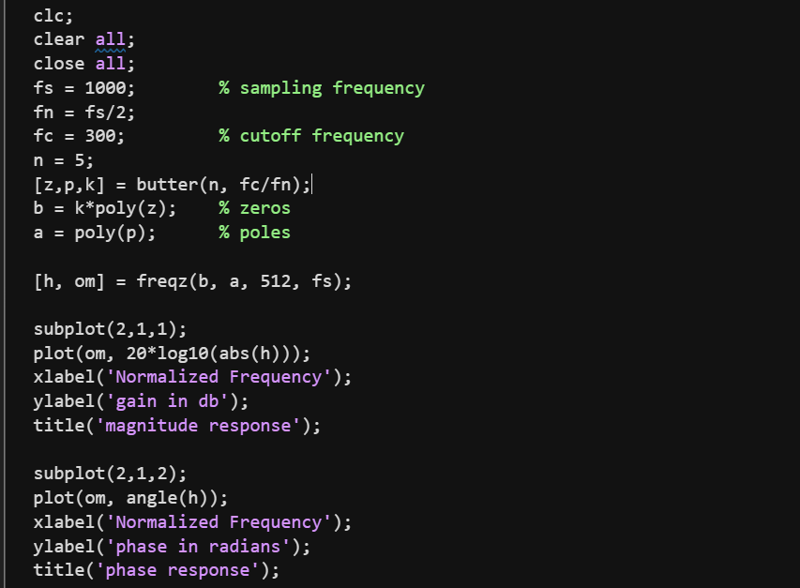
Output:
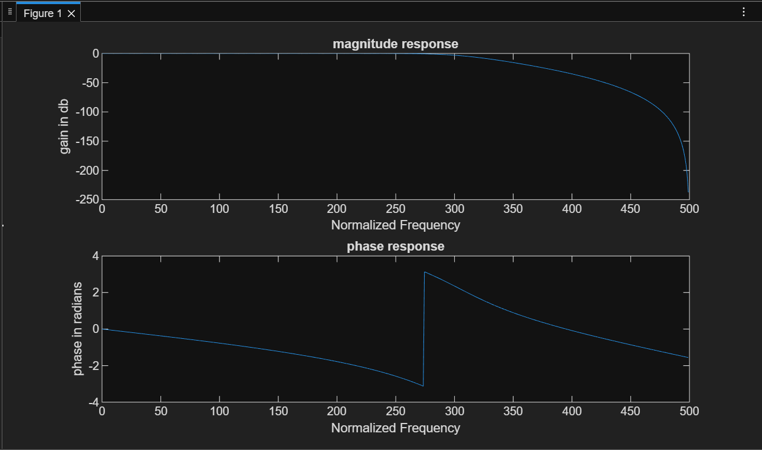
Program 2: Butterworth Low-Pass Filter Design
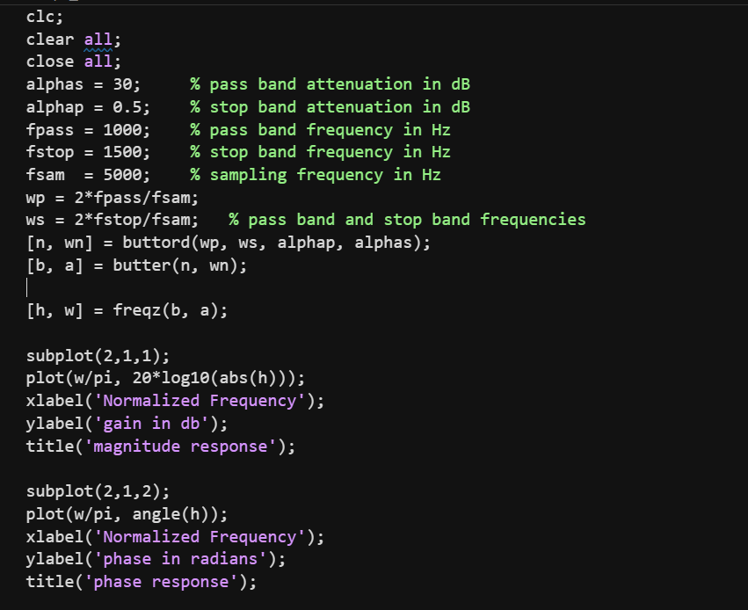
Output:
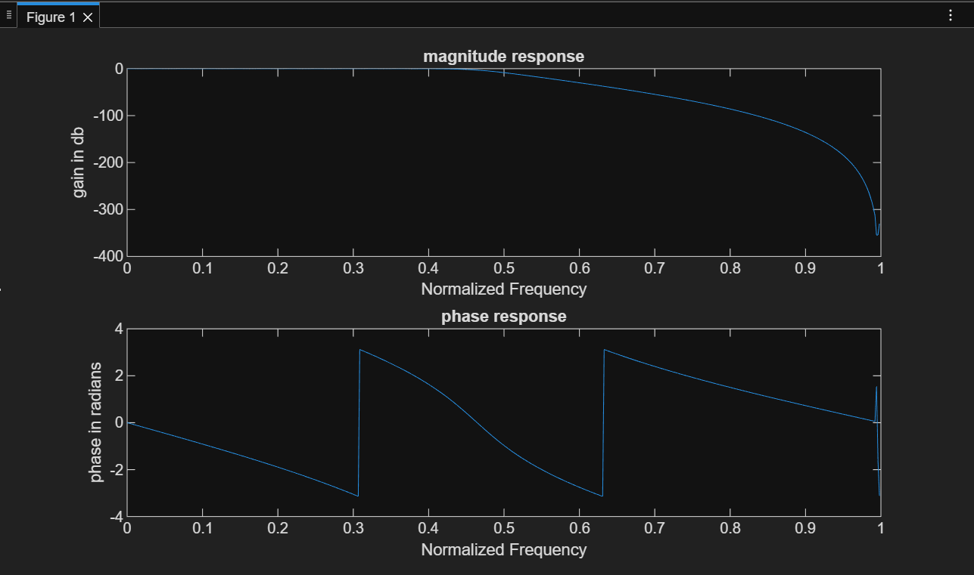
Program 3: Butterworth High-Pass Filter Design
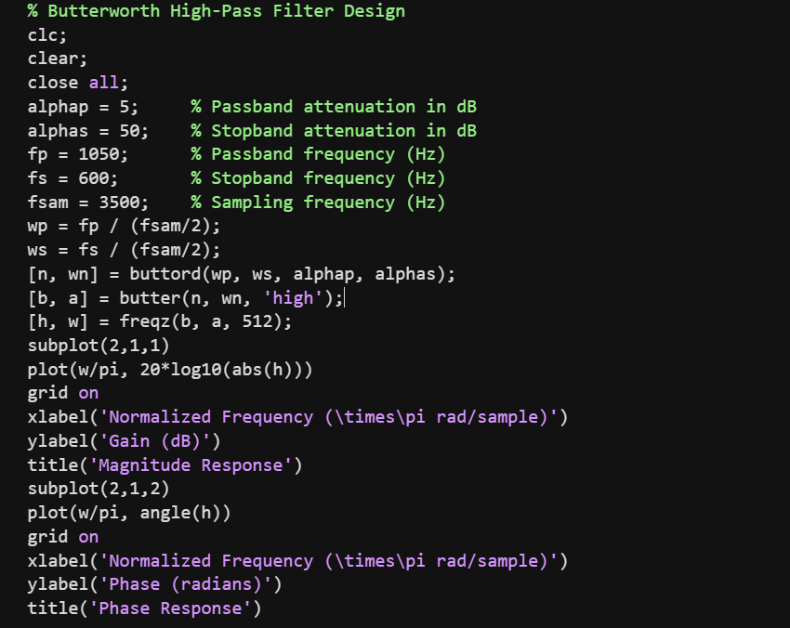
Output:
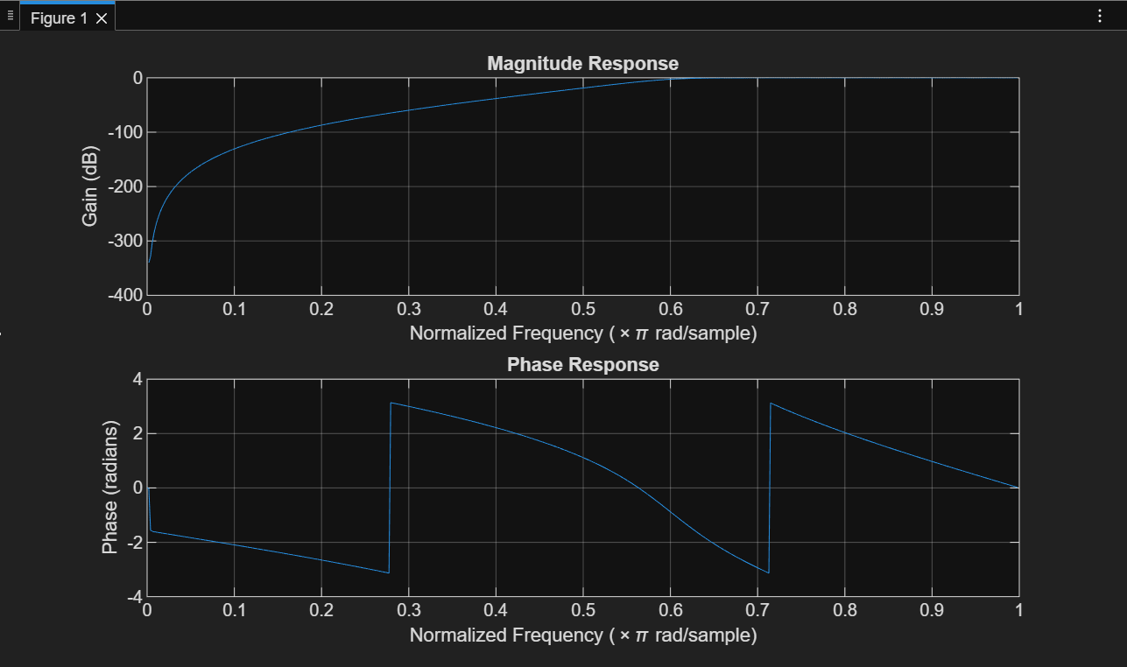
Result:
- Butterworth low-pass and high-pass filters were designed successfully.
- Magnitude and phase responses matched theoretical expectations.

Conclusion:
This experiment demonstrated the design of IIR Butterworth filters using bilinear transformation. The frequency responses confirmed the effectiveness of Butterworth filters in digital signal processing.

